**Software Engineering 2: Design – Assignment 2**

**Task 1 - Main users of the Football Score Display Application**

Football is one of the most popular sports in the world, so being able to display the results of a match quickly and easily to fans and supporters is crucial in modern society, where most all information can be obtained with a quick internet search. This application allows the user to easy input and export score results from a football match. This application was designed with the Premier League in mind, however, it could be easily adapted to suit any football league in any country.

Fans of football would be one of the biggest users of this application. As it can display the results of matches, users would be able to see how their favourite team did during and after the match. The ease of use with the app will allow them to quick find the result they’re looking for.

Let’s say John, a 20-year-old football fanatic, wanted to view the scores for the recent Manchester United vs. Liverpool match. All he would have to do is load up the program and be able to search for Liverpool and see that the most recent match appears and see that they’ve win. Not only is he happy about the result, he was also able to access the information quickly and elegantly.

News outlets would also find the application to be useful to incorporate in their workflow. As the program in synced up to a database, it would download the results as they are input into the database, so long as there is someone at the match was updating the score as it happens. This could be useful for sports news reporters as it can allow them to already have the results before they announce them on TV, radio and newspapers.

Keith works as the sports news reporter for a local radio station. The radio station may not have the budget to be able to send Keith over to a Premier League match to deliver on-site writing. Instead, Keith would use the application to gather the results as the score is updated on the database with someone who is already there.

The simplicity of the application would allow for anyone to use it, from children (aged 7+), to teenagers (aged 13+), to adults (19+), as the UI is simple enough that anyone can use it

**Task 2 - Storyboarding**

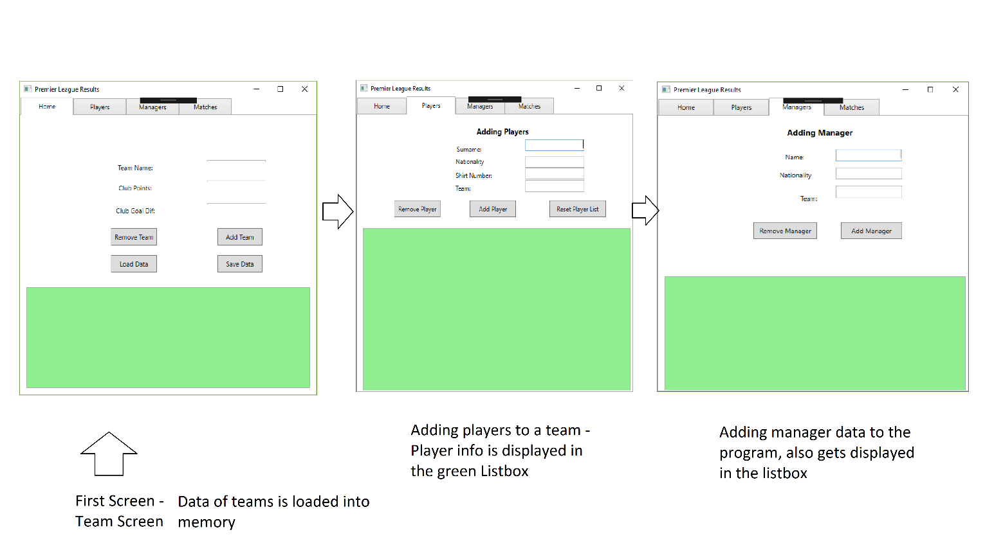

**Task 3 - Program UI**

See the program in action

**Task 4 - Persistent Data**

Data for the application is stored on a database, so there is never any local data that could be potentially out of date. All classes are implemented with the database as they are auto-generated (Manager, Matches, Players and Teams).